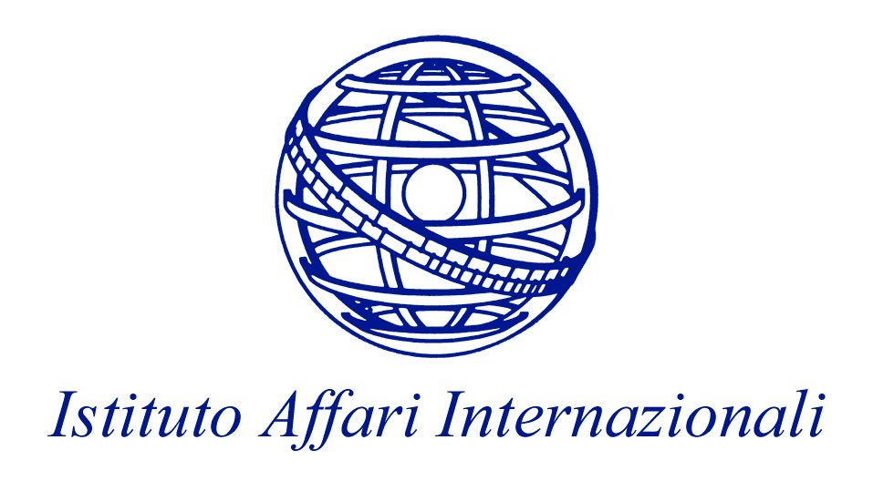

MICROCON

WORK PACKAGE 11
CONFLICTS IN THE EUROPEAN NEIGHBOURHOOD

WORKSHOP

The Nexus between the EU, Civil Society and Conflict
in the European Neighbourhood

19 June 2009

IAI

Via Angelo Brunetti, 9 - Rome, Italy

PROGRAMME

09.00 Welcome and Introduction to the Workshop
Nathalie Tocci, Senior Research Fellow, IAI, Rome

09.15 Session 1: Local and International Civil Society Organisations and Conflicts

Paper Givers:
Nona Mikhelidze, Junior Research Fellow, IAI, Rome, and Nicoletta Pirozzi, Research Fellow, IAI, Rome
Civil Society and Conflict Transformation in the European Neighbourhood: An Overview
Natalia Mirimanova, Visiting Research Fellow, CEPS, Brussels
International Civil society and Conflict transformation in the European Neighbourhood

Discussants:
Walter Kaufmann, Heinrich Böll Foundation, Potsdam

10.45 Coffee-break

11.00 Session 2: Civil Society and Conflicts in Israeli/Palestine and Western Sahara

Paper Givers:
Benoit Challand, Research Fellow, EUI, Florence
Hakim Darbouche, Research Fellow, Oxford Institute for Energy Studies

Discussants:
Riccardo Bocco, Professor, Graduate Institute of International and Development Studies – IHEID, Geneva
Jacob Mundy, Ph.D. Candidate, Institute of Arab and Islamic Studies, University of Exeter

13.00 Lunch

14.00 Session 3: Civil Society and Conflicts in the Post-Soviet Space

Paper Givers:
Nicu Popescu, Research Fellow, ECFR, London > Paper presented by Nathalie Tocci
Licinia Simao, Research Fellow, CEPS, Brussels
George Dura, Research Fellow, CEPS, Brussels

Discussants:
Mira Sovakar, Caucasus Projects Manager, Conciliation Resources, London
Dessislava Roussanova, Projects Manager Eurasia Programme, International Alert, London

Dennis Sammut, Executive Director, The London Information Network on Conflicts and State-building, London

16.00 Concluding Remarks
Nathalie Tocci, Senior Research Fellow, IAI, Rome

